**what is software ?**

software is collection of program which is used to perform a specific task and we can say that software is collection of instruction,data or program that tell a computer what to do. it is use for user and they can do many activities.

for example=>management system, erp system MS-Word, MS-Excel, PowerPoint

**type of software?**

* application software
* system software
* program software

**application software**

application software is design to perform a spacific task for user there are many functionality. it is use gerenal purpose. in that application user can delete update write something and menuplate or upload. there are many feature.it is written by high level language like python ,java etc.

for example=>ms office and any management system, irctc and many more.

**system software**

system software is basically it is control hardware program such as cpu,moniter,keyboard and storage device etc. it is controll the internal functional of system. it is define how to run the computer as we know that computer is understand machine language and it communicate with end user and machine language.it is also to start and close the computer.

for example=>operating system cpu,printer,hardisk,driver, mac os, apple linux.

**program software**

programing software which is responsible for build the software. there is programming languages to make the software in that case should knownledge of programing language like python java c c++ and also.

for example=> c c++ java python

**what is software testing ?**

software testing is process which is provide high quality of software applicaiton in this software testig we check the correctness performance usability and check the security of software applicaiton. we check the error and bug in software applicaiton and also check the software applicaiton is working properly according to the client or not software testing is many type of testing like unit testing and integration testing system testing and uat testing the main goal of software testing is identify the bug and error to fix it and then realse to the public.

**what is manual Testing ?**

Manual Testing is a process where Test the application without any tool and scripts. It is identify the feature and function and ensure that expect result and meets the requirement.

**why important software testing ?**

1. find the errors and bug
2. check the security of software application
3. meets the requirement of client
4. check the performance
5. identify the issue and defect

**what is bug/defect and error and failure?**

**bug**=>A bug is an unexpected behavior which is give the wrong information.during the testing actual and expect result not match that called a bug and defect.

**error**=>A error is an invalid input . it is logicaly mistake by developer .it’s come during the develope time.

**failure**=>A failure is an the software is crashes or hangs. the software produces incorrect result.

**what is reason coming bug and defect errors also?**

* due to lack of communication between stakeholder and tester.
* unskilled
* requirement is not clear
* project complexity
* time pressure

**what is testing and debugging ?**

**testing** is a find the bug.

**debugging** is a fix the bug.

**what is SDLC software development life cycle ?**

software development life cycle is a process of how to develop the software with planning and systmaticaly.

the SDLC define of software development step by step. the main goal is SDLC to deliver high quality product to client.

**here is many phases to develop the software**

* Requirement
* Designing
* Development(coding)
* Testing
* Implementation(deployment)
* Maintenance

**Requirement**

Here analysis the requirement of the client they.there is inforamation of building project

**Designing**

Here is Designing part after the requirement they designe the software as per as requirement.

**Development**

Here is develop the software according to design and it is releted to coding part where development the feature of software.

**Testing**

Here is testing phase which is check the software quality find the bug and error in software and provide high quality software and check meet the requirement of client.

**Implementatioin**

Here is deployement phase in this we deliver the software application for the public.

**Maintenance**

For mainten the software application.

**project manager**

project manager responsible for planning,executing and closing the project. He focus on tasks,timeline and resources. A project manager ensure that project timely compelete.

**Product manager**

product manager who identify the customer requirement.product manager align the product with market needs and business goals.

**Here is many types of SDLC**

* **Waterfall modal**
* **Prototype modal**
* **Iterative modal**
* **v & v modal**
* **Spiral modal**
* **Agile modal**

**what is waterfall modal**

**Requirement /gathering/analysis**

**Desinging**

**Development/implementation/coding**

**Testing**

**Deployment**

**Maintenance**

First of all watermodal is process of software development life cycle.Earlier this modal was very popular but nowdays it is not used.Here is phase do not overlap with each other it is know us linear sequetional modal .this modal sutable only mini project .Here is requirement are not change.if you are going to next phase must be done first phase completely. you can not allow to back step.

REQUIREMENT

DESIGNE

DEVELOPMENT

TESTING

DEPLOYMENT

MAINTENANCE

**Advantage**

* Requirement are clear.
* Project is not complecated.
* Easy to understand.
* work well smaller project.
* taking less time.

**Disadvantage**

* can not requirement change.
* it is not good for complex project.
* testing will be start after coding.
* if one step is wrong then all step is going to wrong.

**Prototype modal**

The Prototyping Model is one of the most popular modal use to SDLC.This model is used when the customers do not know the exact project requirements beforehand. It is based on user feedback the SRC document is finlized.

Here the customer is shown the dummy software before making the actual software.

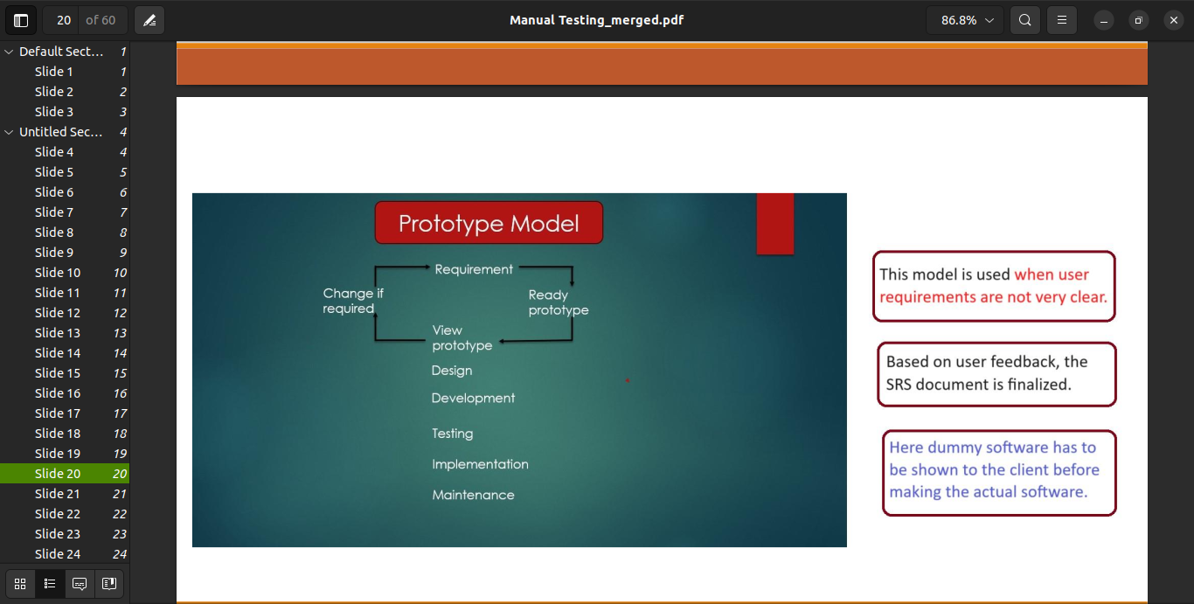

**Advantage:**

* This modal is flexble in designe
* It is easy to detect errors
* You can easly change the requirement
* Reduce maintenance cost

**Disadvantage:**

* No feedback path
* Not sutable for long project or complex project
* It is time consuming process.
* Prototype is exprensive

**Iterative modal**

Itrerative modal is software development life cycle which is provide software is develop part wise according to the client and in this modal we show the project again and again .there is itretation is not fix it is depends on software application.Here risk is very less because requirement is much detail.In this modal testing and debugging is easy to understand because smaller iteration.

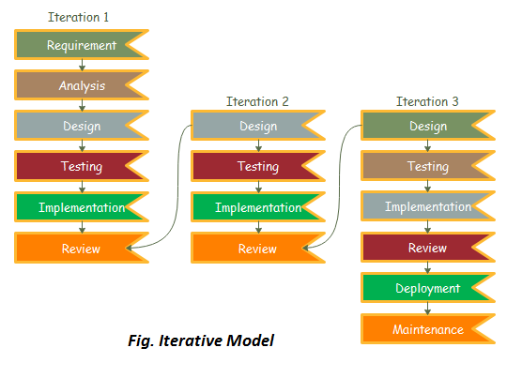

**Advantage:**

* Easly change the requirement
* Testing and debugging is easy beacuse samaller iteration is here
* Requirement is much detail.
* Sutable for large project

**Disadvantage:**

* Not sutable for mini project
* 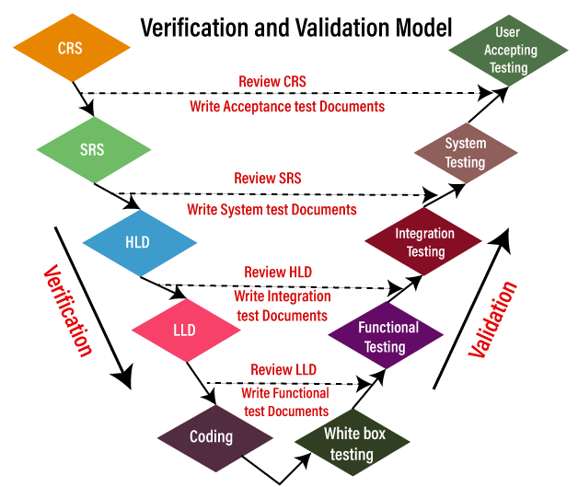Time taking
* Costly

**V & V modal**

brs=business requirement specification

non technical team

srs is technical team

srs=software requirement specification

urs=user requiremnt specification

crs=cusotmer requirement specification

First of all it is software development life cycle.it is follow process of waterfall modal and it is also refer to as verification and validation modal where is include static and dynamic stage there is checking the document and software are develop according to the client or not.Here is all the phases is assocated with each other.

**Verification:**

verification process which is releted to document in this process code is not execute. verification is identify the document weather product is building right or not. verification process activiteis are involve like review walkthough and inspection it is also known as black box testing and static testing.

**Validation:**

validation process which is related to dynamic testing in this process code execution involves validation process also included white box , black box , integration testing , system testing and UAT testing. validation find the bugs

in this process we ensure that meets the requirement of software according the user. validation is checking the product is right or not.

**Dynamic testing:**

Dynamic testing which is related to system testing,functional testing, integration testing and user acceptance testing. it is also known as white box testing. Dynamic testing check the behavior of software with different inputs and conditions. it is identify the physical response of software application. The main purpose test the software behavior. dynamic testing it will be look at the functional behaviour of software system.

**Static testing:**

Static testing which is releted to document all the document review by (**BA)** like **CRS,BRS,URS.** After review this document converted into **SRS** which is prepared by **project manager** and development team also invovles preparing the **SRS.**When **SRS** is ready then go to desige team they make **HLD** basis of **SRS** After design team make **LLD** they prepared a small module which is review by the design team and then go for development team

which is releated to coding part they build the software acooring to requirement. static testing analize the code,requirement document and design. Testing project related document is called **static testing.**

**There are three type review**

* **Technical review**
* **Walkthrough**
* **Inspection**

**Technical review:**

review is process analysis the document to detect the defect. in that case they ensure that correctness and completeness of document.Here technical reviewer will read the document before the meeting for better understand and to give suggest of document.leed by the moderator.

**There are four participants**

**1)The moderator:**

He is responsible for distributes the document before meeting.He scheduling the time of meeting.Moderator leeds the review process.

**2)The scriber/recorder:**

He is responsible for the record or note each defect and comment or suggestion or defect.

**3)The author:**

Auther is writer or prepare of the document under review.

**4)The reviewer:**

To check defect to further improvement.

**Which type document review:**

* requirement
* design
* code
* test plan
* test case

**Walkthrough:**

It is informal review in the author read the document and discuss with peers so that they note out defect and suggestion and it is not preplanned and it can be done whenever is required.

**Inspection:**

it is formal review type. in which author request the service of moderator. The moderator destributes the document in between participant during meeting and scriber take a notes of issue during the meeting.

**Testing teckniques:**

* **white box**
* **black box**
* **grey box**

**white box testing:**

white box testing which is releted to coding there are tester know about he internal structure of the software application. it is done by the developer.

other name of white box testing like glass box testing,visible testing, transparent testing, clear box testing.

**Black box testing:**

in black box testing tester does ‘t know about the interal structure of software application.

**Grey box testing:**

in this type of testing tester have a experience based knowledge of internal structure of software application. it is combination of white box testing and black box testing. the other name of grey box testing is experience base testing.

**QA(quality assurance):**he is responsible for software development life cycle.

**QC (quality control):** he is responsible for find the bug issue and defect that remain after the development. **QE (quality engineers):**write the code for testing is called QE. like automaiton testing.

**There are four level of testing:**

1. **unit testing =done by developer**
2. **integration testing =done by tester**
3. **system testing =done by tester**
4. **(UAT)acceptance testing =done by user**

* **unit testing:**

unit testing is a type of software testing where individual unit tested .its done by the developer which is include white box testing. there is person who have a knowledge of programming languages.unit testing is single component.

* **integration testing:**

In this integration testing we check the data flow of one module to another module there are module connected to each other.

**Apporach of integration testing:**

**1)top down integration testing:**

in top down integration testing there are test the high level module means main module to sub module.in that case use **stubs. Stubs** When sub module is missing or under development or not available then they use stubs.

**2)bottom up integration testing:**

in bottom up integration testing firstly test the low level module where main module is missing. In that case use to **Driver. Driver** it is use when main module is missing or under development or not available they use driver.

**3)sandwich testing:**

first of all it is combination of top down integration and bottom up integration testing. it is also called a **Hybrid inegration testing.** It use both which is stubs and drivers.

**4)big bang testing:**

in this testing all units link together.without big bang testing integration testing is not execute.

**5)incremental testing:**

incremental testing is one of the method which is used to integrate the modules one by one using stubs and drivers. incremenal tessting is a integration testing where use stub and driver which is used to check the different module.

* **system testing:**

system testing is type of software testing system testing is perform on integrated system. it is define overall functionalty. system testing in invovles like perfomance testing,load,stress and scalability testing.

there is no require more knowledge of programming language.it is also called a black box testing.

system testing focus on like **gui testing,functional testing,non-functional testing,usability testing.**

**System Testing Process: System Testing is performed in the following steps:**

* **Test Environment Setup:** Create testing environment for the better quality testing.
* **Create Test Case:**Generate test case for the testing process.
* **Create Test Data:**Generate the data that is to be tested.
* **Execute Test Case:**After the generation of the test case and the test data, test cases are executed.
* **Defect Reporting:** Defects in the system are detected.
* **Regression Testing:** It is carried out to test the side effects of the testing process.
* **Log Defects:** Defects are fixed in this step.
* **Retest:**If the test is not successful then again test is performed.
* **UAT Testing:**The purpose of User Acceptance Testing (UAT) is to identify bugs in software, systems, and networks that may cause problems for users. UAT ensures that software can handle real-world tasks and perform to development specifications. Users are allowed to interact with the software before its official release to see if any features were overlooked or if any bugs exist.

**[Alpha Testing](https://www.geeksforgeeks.org/alpha-testing-software-testing/)** is a type of software testing performed to identify bugs before releasing the product to real users or to the public.

**Beta Testing** is type of software testing  This testing executed after the alpha testing. Beta testing direct feedback from the customers.Beta testing used in a real environment .Beta testing helps in providing the actual position of the quality.Testing performed by the client, stakeholder, and end-user.

**How many types of testing:**

**1)function testing**

**2)non-function testing**

**functional testing:**

Functional testing is a type of software testing in functional testing we have to test the behaviour of software application we will test the application ui and database working or not. we test what product does. it ensure that functional are correctly working or not. the main purpose of functional testing meets the specific requirement as function expected.

such as.

* input output validation.
* error handling.
* data validation.
* compatibility testing.
* cookie testing:it is browser releted text file.

**unit testing**:where the individual units or modules of the application are tested. It ensures that each module is working correctly.

**integration testing:**where individual units are tested as a group we check data flow one module to another module.

**smoke testing:**smoke testing is performed after software build to find the critical/basic functionalities of the software working find .this is check weather software is testable or not.

**sanity testing:** it is performed on stable build to verify the basic feature/high lavel feature of the software is working or not. in the application which is functionality modified or fix the bug we test the that part feature affected or not and working good or not.

**regration/retest testing:**regration testing is type of softeware testing where check that whatever the reason to modify in feature due to that modify the feature the other feature has been not affected and the product is working properly or not that called regration testing.

**Type of regration testing:**

**unit regression:** in this testing only change feature or fix or modified it’s called unit regression.

**partial/regional:**in this testing whatever the reason for change the feature like bugs, new requirment

that feature related to all module we have to check the all area which is related.

**complete regression:** in this testing the modification along with the remaining areas.

**retesting:**re-testing means the funcionality or bug again to ensure that bug is fix in this case the process of fixing bugs will continue until it is fixed.

**Adhoc testing:**it is a informal process. It is performed after formal testing. There is no documentation.there

is no test design .there is not test cases. Mostly negative test scenarios are tested with a aim to break the system.There is not requirement space. The effectiveness of adhoc testing depends. In this we check application without any sequence or procedure randomly and find some issues.

**exploratory testing:**in this testing, first application under test is explored, flow of application is understood

then test case is designed and test cases are excuted. This testing is perfomed when requirement is missing. This is also informal testing process. It involves test design and control and notes are taken progress is also tracked.It helps to study the product and argument the document and also research the bug.

**stability:** we test the behaviour of the software application with increse in use or load.

**instability testing:** we check the software installs and uninstall is correctly or not.

**sanitation/garbage testing:** during this testing tester are finding extra functionalty in build according to the customer requirement.

**Database Testing:** Database testing is a type of software testing that checks the schema, tables, etc of the database under test.

**non-functional testing:**

in non-functional testing we check the performance reliability scalability ,load ,stress,and other non-functional aspect of the software application. it ensure that how good the product works example of non-functional testing like load,stress,security testing. it is define how much fast give result as per request. it is improve the ux.

**perfomance testing:**

in this testing we ensure that speed stability and scalability.there are load testing,stress and valume testing.

**stability:**

we test the behaviour of software application when user number increase.

**scalability:**

we check the break point of software application.

**load:**

in load testing we will slowley increase the load on the software check the response time and speed of applicatoin.

**stress:**

in stress testing we will incresase the load suddenly and then check the responese time and speed of application.

**valume:**

in valume testing we will give load on the server which is check the database behaviour of the software application. How much data application is able to handle.

**compatibility:** in this is testing we check the application is compatibale with diffrent environment like web browser hardware plateform and database ,operating system networks diffrent version confifuration etc,we ensure that our application ia works without issue in diffrent environment.

**===>backword compatibility:** we check the application behevior and compatible for old version which is we created the new version.

**===>forward compatibility:** we check the applicaiton behevior and compatibile for new version.

**security testing:** we ensure how is secure our application and ensure that data loss.

**authentication:**who you are

**authorization:**what you can do in software application and what he access.

**recovery testing:** checks that application terminates gracefully incase of failure and data is recover in this testing Is it able to recover data.

**For ex:** microsoft docs. Bin ,trush we can recover of loss data by mistake.

**Gui testing:**

it is sortware testing type that ckeck the graphical user interface of the softwre to ensure the functionalities of the software works as per requirement specification.

**Checklist for gui testing:**

* all the gui elements for size position width lenghth and acceptance of charaters or numbers.
* error emssages & warning message are displayed correctly.
* for clear demarcation of different sectiosn on screen.
* font used in an application is readable.
* alighnment of the text is proper.
* color of the font and warning message is aesthetically pleasing.
* images have good clearity and they are properly aligned.
* positioning of gui elements for diffrened screen resolution.
* execution of the required funcitonality of the applcation using the gui .
* test the color of the hyperlink.
* check for spelling mistake.
* test the scrollbar according to the size of the page.
* test the headings whether it is properly aligned or not.

**usability testing/user experience testing(ux testing):**

* in usability testing we check the application for use friendliness efficiency and accuracy.
* easy to understand
* easy to access
* look and feel
* faster to accesss
* effective navigation
* good error handling

**monkey testing:** this test is also random in nature therefore test cases are not used in monky testing. Monkey testing can be performed by an individual who does not have a good knowledge of the application. Tester test randomly by clicking on random object and entering the random and invalid data to check is the application give an error or not.Monkey testing is a type of software testing in which a software or application is tested using random inputs with the sole purpose of trying and breaking the system.

**positive testing:**in positive testing ,tester always checks application with valid set of input. tester check whether an application behaves as expected with the positive input.

* **Ex=>** the password text box should allow charactors input.
* .the password text box should allow 15 charactor of input.
* .any values between 8 and 15 charactor long should be accepted by the password text box.
* .it should accept combinatioin of letters and numbers in password text box.

**negative testing:**tester cheks an application with invalid set of input.checks whether an application behaves

as expected with the negative input. This is to test the application that does not do anything that it is not spppose to do.

**Ex:=>**the password text box shoud an error or should not accept when less than 8 charactor are entered.

.the pasword text box should throw an error or should an error or should not accept when more than

15 charactores are entered.

.the password text box should not accept special charactors as input.

.the password text box should not accept a combination of numbers only or a combination of letters

only

**end to end testing:** in e2e testing ,tester checks the flow of application from start to end. In e2e testing, tester create an enviroment identical to the one that will be used by real user. Then tester test all actions the user might perform on the application.

**test design techniques:**A test designe technique is a systematic approach use by the tester which is helps to how to create a test case and test scenario in better way based on specific requirement it is allow to tester identify the defect and ensure software meet requirement.

Increasing test coverage i.e to cover each and every area of the feature. It help to prepare test data.

**Type of test case design technique**

**Equivalent class partitioning(ecp):**=>Equivalent class partitioning is a technique where we test the input data into groups.

**boundary value(bva):**Boundary value analysis focuses on testing the boundaries of input ranges, such as minimum, maximum, and just beyond these limits.

min=18 valid

min-1=17 invalid

min+1=19 valid

max=35 valid

max-1=34 valid

max+1=36 invalid

**descision table/caus-effect table:**this technique is appropritae for preparing test data to test funcitonalties which has logical relationship.

**Ex=>** login page validation. Allows user to login only name aad password are correctly entered.

**state transition testing technique:** this technique is used when feature of a system are respresented as states which transorms into one another.

**Ex=>** ATM user only have 3 attempts otherwise block.

**Error guessing technique:**=> error guessing is a software testng technique in which the tester uses their experience of prior testing & intuition ot guess the types of errors that might occur in a system, and then tests for those specific errors. The guessing is best used to supplement other testing techniques and methods to identify defects tat may have been missed by other approaches.

**Ex=>** invalid email address formates.

Password too week.

User profile not saver properly.

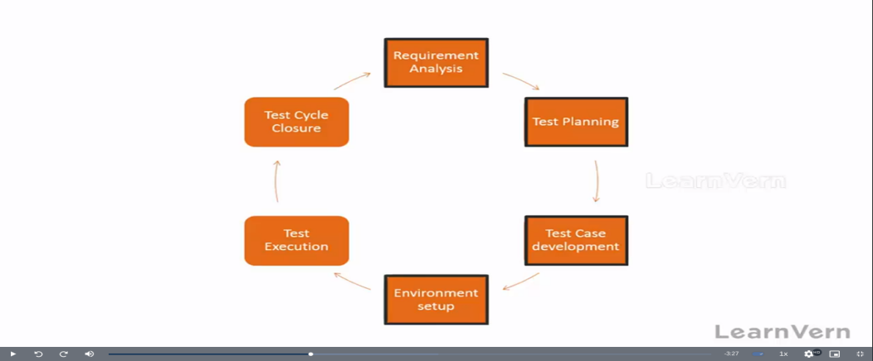

**What is STLC:**the software testing life cycle testing

of the software application it is ensure that meet the

requirement and is free of defect and it is also ensure

that testing the software high quality and what is

need of end-users. The main goal is identify the

defect and issue in the software anpplicaiton resolve

the all thing before released to the public here is 6

phases these are stages ensure that tested and meets

the requirement of the end-users.

**What is agile modal:**

It is life cycle of software development agile model is combination of iterative and incremental process.

**Incremental process** incremental means add on new feature in to existing software.

**Itterative** iteration means again and again that mean here deliver the software product in part wise according

to client requirement on the basis of priority.

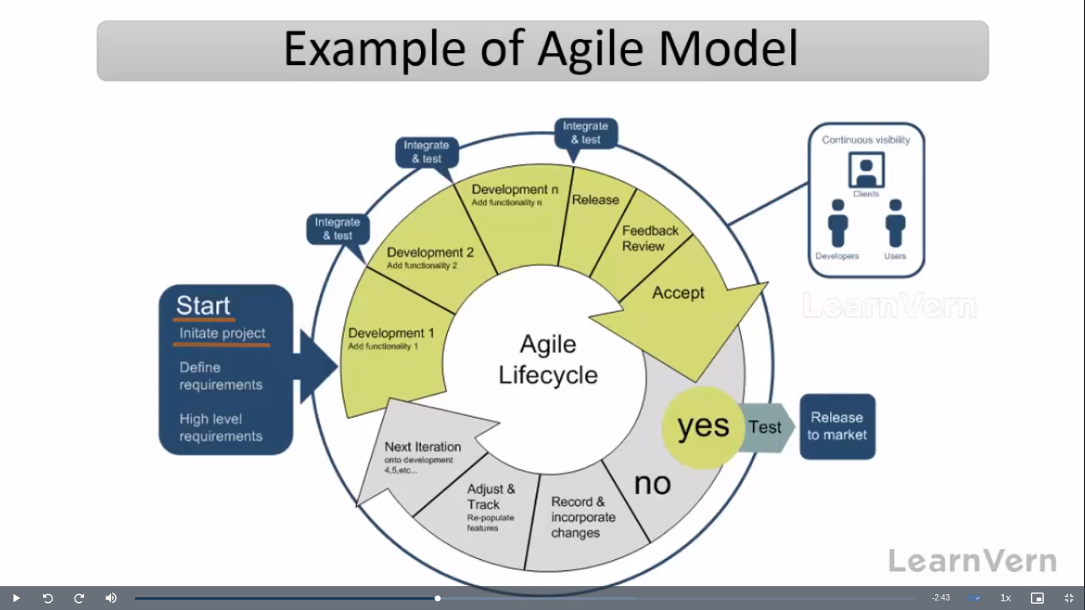

**Note:** there are some main frameworks of agile modal such as scrum kanban extreme programming(xp) etc.

The framework provides a structrued way of applying agile principles for which we use jira tool.

**agile principles:** customer no need to wait for long time we will deliver piece of software which contains some functionality according to client requirement on the basis of priority.

Easily adopt to changes.

**Advantage of agile model:**

here we can add on new feature in existing software.

Release will be very faster.

Requirement changes are allowed in any stage of document.

There is good communication between customer product owner developer and tester.

**Disadvantage of agile model:** lack of comprehensiv documentation

dependency on customer availability.

**Product owner:**

He is agent of client .He is define feature of product he decide feature according to the market value and he is responsible for close and reject the project.

**Scrum master=>** scrum master acting as leader.He will facilitating and driving agile process. he is acting as leader. he is coach of scrum team. Scrum Master facilitates all Scrum events, including Sprint Planning, Daily Stand-ups, Sprint Reviews, and Retrospectives.

**Other team:**

there is -5-10 member where is developer and tester and they are responsible for build the project and also test the project.

**Scrum team=>**at the begning of each sprint the team selects items from the product backlog,defning them

as the sprint backog. They discuss each other.

They are involve in scrum team =>product owner scrum master developer team

they are involve in scrum team scrum team members decide how to do the work and overcome challenges.

**Product backlog=>** it is container where is a list of user stories and epic which is prepared by product owner.

**Sprint backlog=>** it is a subset of product backlog.

**Sprint planning meeting=>** in this meeting define what can be delivered to the team in the sprint duration.

**Sprint=>** it is span of time complete user stories. It is decided by product owner and team. Sprint will be

changing company to company but minimum duration is 2-4 week.

**Daily scurm meeting(standup call)=>** it is conducted 15-20 mintues on daily basis. In stand up call mainly focus on what did the task compelted yesterday, what are the task today and what are the task plan for tomorrow and share if any face challenges or blocker. This meeting coducted by our senior such as QA manager and test lead.

**Scrum=>**scrum is a framework through which we build software.

**Sprint review=>** a sprint review is an informal meeting held at the end of a sprint, during which the team

shows what was accomplished, while the stakeholders provide feedback.

**Scrum framwork=>** the scrum framework provides a structured and flexble approch to software develop

it consists of roles and events also.

In this have product owner scum master development team. And sprint ,sprint planning,daily scrum, sprint review, sprint retrospective.

**Sprint retrospective=>** the sprint retrospective is a recuming meeitng dedecated to discssing what went well

and what can be improved in a sprint. It also gives a chance to recover from sprint and prepare for the next one.

**Burndown=>** burndown chart shows how much work is remaining to be completed.

**Burnup=>** burup charts shows how much work has been completed.

**Story point=>** it is the rough estimation of time that mean how much time is required to complete a specific user story. Story points are given by developer and QA.

**what is workflow of agile methology:**

**product owner** take requirement from the **customer or stakeholder** and the keep product backlog there is user stories and then all people decide about the user stories and select one item for give the **developer and tester** basis of priorty.when asign the item then next go for **daily scrum meeting** there is **QA** they ensure that what did he last day and what will do tommorow and what did plan today for work it is atleast 15-20 min taking time.accroding to dailay scrum meeting make a chart burdown and burnup. and then go for the **sprint reviewer** they ensure that how many project compeleted in that case if any change or new request product owner write the note and update the backlog and product owner take final decison on acceptance.it is informal meeting and then go for **sprint retrospective** for imporve and people are discuss about the emprove area what can be improve.

**Scrum ceremonies:**

scrum ceremonies are meeting.there are include product owner scrum master and developer and they discuss about the progress ,gather feedback and more. there are five ceremonies.

**sprint planning**

**daily scrum meeting**

**sprint review**

**sprint retrospective**

**product backlog grooming**

**product backlog grooming:**it is regular session and it is also known as backlog refinement they ensure ranking essure and it is continues process of updating backlog they are disscus about the backlog item.

**Jira tool**

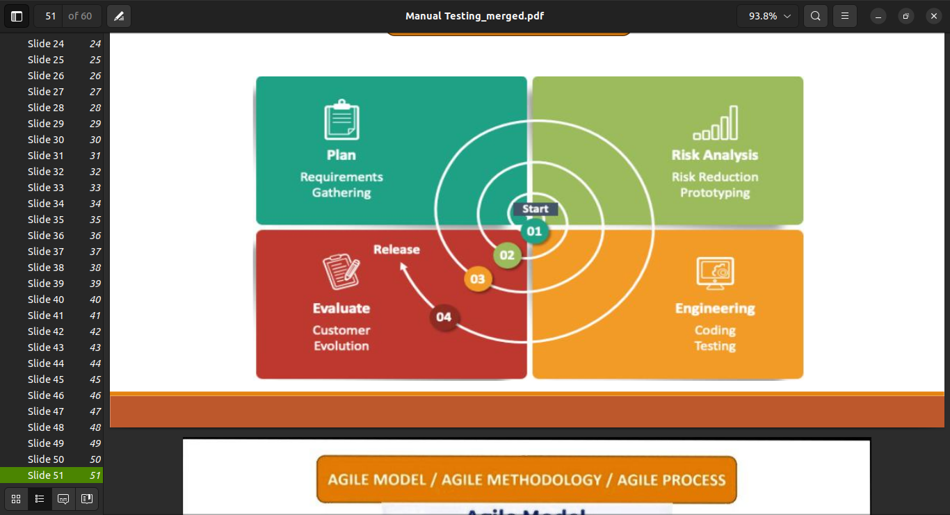jira work management =>business project

jira software =>software project

jira service management=>service project

**spiral model/version control/ model in sdlc**

in this model we evalute the client again and again

you can modify the requiremnt according to the client

it is suitable for large project or where there is

dependency in modules.This process runs like a loop

analysis the risk in every phase becomes a necessary

where we can use spiral modal.We can also called

the meta modal because it is follow the multiple modal.

**planning**

**requirement/gathering/cost-effective/resourece allocation**

**risk-analysis**

**strenghts and weaknesses of the project**

**desgine**

**coding internal testing and deployment**

**evalution**

**client evalution(client-side testng) to get the feedback**

**Advantage**

it allow the requirement

suitable for large project

it allow better risk analysis

cost-effective good risk management

**Disadvantage**

not suitable for mini project.

there is no testing requirement and desgin phases.

its depends on risk analysis phase.

expensive.

complex.

time taking.

**What is jira tool:**

jira is a product management tool in which we track project work status team work and also track bugs and issues.

it is use to team work and time tracking. project work and bug can mange easly.team can communicate over the project. multiple project handle.chart and graph will help to project progress

**why we need jira tool:**

* no need to make excel or any other document
* project work and bugs can mange easily
* here multiple project can handle.
* team can communicate over the project.

**who use jira tool**

jira tool is used by software developer **QA** which are called testing team, product owner and also used by team manager and management.

**jira provide a multiple project**

* jira work management=>business project related
* jira software => software project related
* jira service management=>service project related

**Developer Tasks**

Understaning Requirement

Design

Coding

Unit Testing

Integration Testing

Code Review

Bug Fixes   
Team Meetings

Any other

**QA Tasks**

Understanding Requirement

Writing Test Scenario

Test case Review

Test Data Preparetion

Test Enviorment Setup

Test Execution

Re-Testing Bugs

Team Meetings

Automation

Any Others..

**Defect/bug life Cycle:**

The main purpose of defect/bug life cycle to find the cycle the defect and error in our software application, and make the defect fixing process there are **Developer and Tester.**

**tool=>**jira, trac etc.

**New**

**reopen**

dublicate

reject/deffered

note bug

**Assigned**

**Open**

**Fixed**

**Retest**

**Verified**

**Close**

**new:**

* find the bug.
* send the defect development team.

**assigned:**

* the team work on defect.
* try to fix it.
* if they feel it is not defect the go for the reject or deffered.

**fix:**

* developer team take action for the defect and fix it.

**Retest:**

* the tester team do the test and check defect is fix or not.

**verify:**

* they pass out the defect is fix.

**close:**

* then they close the issue.

**what is test case ?**

A test case is action whcih is verify the functionalty and requirement of software testing.

**what is test scenario ?**

A test scenario is specific situation to validate software functionality and behavior.it is collection of test cases.

**Priority:** Priority is a term that defines how fast we need to fix a defect.

**Severity:** impect on business.

**Use case:**what is describe in requirement

**Database Testing:**

A database is large amount fo data. where store data on server. it is easy to manage to data where you can also update and create delete and more. the data orgnized into table,rows, columns and,indexs etc.

**Data:**

Data is a collection of information like:

|  |  |  |  |  |  |
| --- | --- | --- | --- | --- | --- |
| **name** | **age** | **number** | **picture** | **phone** | **color** |

**Table:**

Table is a collection of data which is orgnized as rows and columns.

**Rows:**

A rows is horizental alignment of data.

**Columns:**

A column is a vertical alignment of data.

**Field:**

A field a title of data.

**Record:**

A record is collection of data which is horizental formated in relational database.

**Type of database:**

**RDBMS:**  
Relational Databases: A relational database’s contents are arranged as a collection of tables with rows and columns. Accessing structured data is made most flexible and efficient by relational database technology.

data save as a table form and related from each other it is readable.

**Ex:my sql server,postgre sql,oracale.**

**NO SQL:**

NoSQL Databases: Unlike relational databases, which specify how all data input must be formatted, NoSQL, or nonrelational databases, permit the storing and manipulation of unstructured and semistructured data. The prevalence and complexity of online applications led to the rise in popularity of NoSQL databases.

not a save table form and no sql database are document based document type.

**Ex:mongodb,radis,cassandra** **etc**

**DBMS:**

some dbms ex:**oracle ,mysql ,mongodb,postgre sql,mysql server.**

**HOW TO INSTALL SQL**

install xamp, wamp, mamp my sql workbrench.

**Database testing:**

database testing is a type of software testing that checks the schema, tables, triggers, etc. of the database under test.where involves creating complex quries.basicaly a database testing about checking exact values which have been retrived from a database by the application. data should be correctly matches as per the records that are stored in the database.

|  |  |
| --- | --- |
| **NO SQL** | **RDBMS** |
| data store as a file formate | data store as a tabular formate |
| it does not suppport client-serve architecture | it is support client-server architecture. |
| it is support single user | it is support multiple users. |
| it is document based | it is readable and access easy |

**Sql:**

sql is structured query language. sql can delete,update and,create,insert the data from database sql is relational database management system.you can use with multiple language and it is use with cross plateform like linux windows mac and etc.

|  |  |
| --- | --- |
| create database | CREATE DATA demo |
| delete database | DROP DATABASE demo |
| show database | SHOW DATABASES |
| use database | USE DATABASENAME |
| create table with record | CREATE TABLE users(  id INT AUTO\_INCREMENT,  first\_name VARCHAR(100),  last\_name VARCHAR(100),  email VARCHAR(50),  password VARCHAR(20),  location VARCHAR(100),  dept VARCHAR(100),  is\_admin TINYINT(1),  register\_date DATETIME,  PRIMARY KEY(id)  ); |
| drop table | DROP TABLE TABLENAME |
| show tables | SHOW TABLES |
| insert row with detail | INSERT INTO users (first\_name, last\_name, email, password, location, dept, is\_admin, register\_date) values  ('Brad', 'Traversy', 'brad@gmail.com', '123456','Massachusetts', 'development', 1, now()); |
| insert multiple rows | INSERT INTO users (first\_name, last\_name, email, password, location, dept, is\_admin, register\_date) values  ('Fred', 'Smith', 'fred@gmail.com', '123456', 'New York', 'design', 0, now()),  ('Sara', 'Watson', 'sara@gmail.com', '123456', 'New York', 'design', 0, now()),  ('Will', 'Jackson', 'will@yahoo.com', '123456', 'Rhode Island', 'development', 1, now()),  ('Paula', 'Johnson', 'paula@yahoo.com', '123456', 'Massachusetts', 'sales', 0, now()),  ('Tom', 'Spears', 'tom@yahoo.com', '123456', 'Massachusetts', 'sales', 0, now()); |
| select column | SELECT columnname,columnname FROM tablename |
| select all | select \* from tablename |
| select distinct (return only diffrent value) | SELECT DISTINCT column1, column2, ... FROM table\_name; |
| select with where clause | SELECT column1,column2 FROM tablename WHERE column3="column" |
| **Operators in The WHERE Clause** |  |
| = | SELECT \* FROM table  WHERE Price = 18; |
| > | SELECT \* FROM table  WHERE Price > 30; |
| < | SELECT \* FROM table  WHERE Price < 30; |
| >= | SELECT \* FROM table  WHERE Price >= 30; |
| <= | SELECT \* FROM table  WHERE Price <= 30; |
| <> | SELECT \* FROM table  WHERE Price <> 18; |
| between | SELECT \* FROM table  WHERE Price BETWEEN 50 AND 60; |
| like | SELECT \* FROM table  WHERE City LIKE 's%'; |
| in | SELECT \* FROM table  WHERE City IN ('Paris','London') |
| order by | SELECT \* FROM table order by columnname |
|  | SELECT \* FROM table ORDER BY columname DESC; |
| and | SELECT column1, column2, ... FROM table\_name WHERE condition1 AND condition2 AND condition3 ...; |
| or | SELECT column1, column2, ... FROM table\_name WHERE condition1 OR condition2 OR condition3 ...; |
|  | SELECT \* FROM table WHERE Country = 'Spain' AND CustomerName LIKE 'G%' OR CustomerName LIKE 'R%'; |
| not | SELECT column1, column2, ... FROM table\_name WHERE NOT condition; |
|  | SELECT \* from tablename WHERE columnname NOT BETWEEN 5 AND 9; |
| insert | INSERT INTO table\_name (column1, column2, column3, ...) VALUES (value1, value2, value3, ...); |
| update | UPDATE table\_name SET column1 = value1, column2 = value2, ... WHERE condition |
| delete record | DELETE FROM table\_name WHERE condition; |
| min | SELECT MIN(Price) FROM Products; |
| max | SELECT max(Price) FROM Products; |
| count | SELECT count(Price) FROM Products; |
| sum | SELECT count(Price) FROM Products; |
| average | SELECT average(Price) FROM Products; |
| inner join | select \* from tablename inner join secendtablename on tablename.id=secondtablename.id |
| left join | SELECT \* FROM tablename LEFT JOIN tablename on tablename.name=tablename.Name |
| right join | SELECT \* FROM table name RIGHT JOIN table name on tablename.Name=tablename.first\_name |
| add column | ALTER TABLE tablename ADD columnname varchar(100) AFTER City; |
| drop column | ALTER TABLE talbename DROP columname |
| add constraint | [ALTER](http://localhost/phpmyadmin/url.php?url=https://dev.mysql.com/doc/refman/8.0/en/alter-table.html" \t "/tmp/wps-ashman/x/mysql_doc) [TABLE](http://localhost/phpmyadmin/url.php?url=https://dev.mysql.com/doc/refman/8.0/en/alter-table.html" \t "/tmp/wps-ashman/x/mysql_doc) tablename ADD UNIQUE(columname); |
| rollback,and commit | it command only run insert update delete |
| unior for join | SELECT column name FROM tablename UNION SELECT columname FROM tablename; |
| trucate table | it is use to only delete records truncate table tablename |
| create new table as similar othertable | CREATE TABLE tablename like othername; |
| copy all table content,first create a new table use like. then.. | insert into newtable select \* from othertable\_name |
| concate | SELECT CONCAT(  'C', 'o' 'n', 'g', 'r', 'a', 't',u', 'l', 'a', 't', 'i', 'o', 'n', 's')   AS Wishes; |

**API Testing:**

**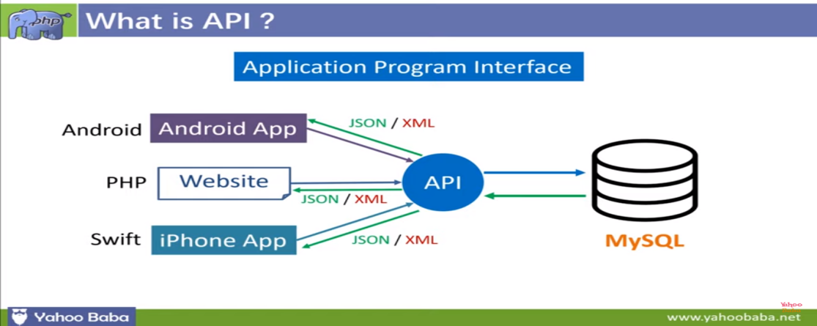**

**\* how web application works ?**

Web applications work by utilizing a client-server architecture. When a user interacts with a web application, their browser acts as the client, sending requests to the server. The server processes these requests, retrieves the necessary data from databases or other sources, and generates a response. This response is then sent back to the client, which displays it to the user. This back-and-forth communication happens through the Hypertext Transfer Protocol (HTTP).

**\* what is client/server ?**

In simple terms, a client/server architecture is a way for computers to communicate with each other. The client is like a customer, making requests to the server, which is like a store, providing the requested information or services. The client sends requests to the server, and the server processes those requests and sends back the response. It's like a conversation between two computers, where one asks and the other answers.

**\* what is api ?**

An API, or Application Programming Interface, is like a messenger that allows different software applications to communicate with each other. It defines a set of rules and protocols that enable one application to access and use the services or functionality provided by another application. APIs make it easier for developers to integrate different software systems and build new applications by leveraging existing functionalities. It's like a bridge that connects different software applications and allows them to work together harmoniously.

**Ex:**

An API is like a menu at a restaurant. It lists all the dishes (functions or services) that the restaurant (software application) offers. When you order from the menu, the kitchen (API) prepares the dish (data or functionality) and serves it to you. Similarly, an API provides a way for different software applications to interact and share data or functionality with each other. It's like a language that allows applications to communicate and work together smoothly.

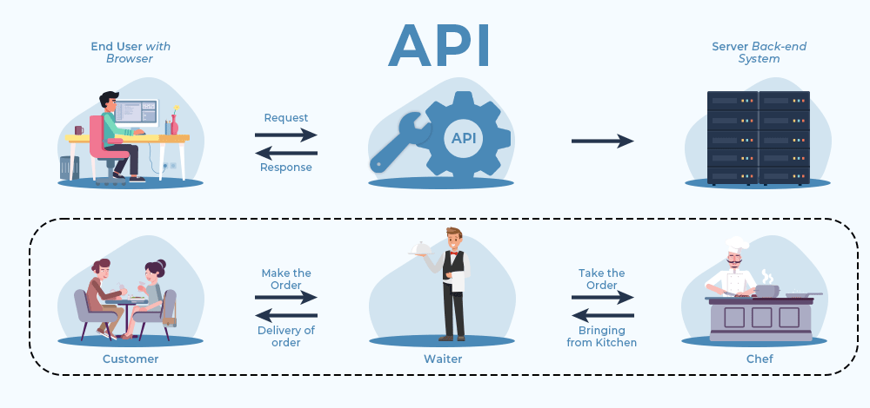

**\* why do we need api testing ?**

API testing is important because it helps ensure that the APIs being used by different software applications are functioning correctly and delivering the expected results. By testing APIs, you can verify that they are properly handling requests, returning the correct data, and handling errors gracefully. This is crucial for ensuring the reliability, functionality, and security of the overall system. Additionally, API testing allows developers to catch and fix issues early in the development process, saving time and resources in the long run.

**\* type of api ?**

**1. WEB API**

A Web API also called Web Services is an extensively used API over the web and can be easily accessed using the HTTP protocols. A Web API is an open-source interface and can be used by a large number of clients through their phones, tablets, or PCs.

**There are 4 http protocols:**

**SOAP (SIMPLE OBJECT ACCESS PROTOCOL):** It defines messages in XML format used by web applications to communicate with each other.

**REST (Representational State Transfer):** It makes use of HTTP to GET, POST, PUT, or DELETE data. It is basically used to take advantage of the existing data.it support multiple file like json, text,xml,user-defined.

**There are 4 Http method:**

* GET (retrieve a record) data read
* PUT/PATCH (update a record)
* POST (create a record)
* DELETE (delete the record)

**JSON-RPC:** It uses JSON for data transfer and is a lightweight remote procedural call defining a few data structure types.

**XML-RPC:**It is based on XML and uses HTTP for data transfer. This API is widely used to exchange information between two or more networks.

**2.LOCAL API**

In this type of API, the programmers get the local middleware services. TAPI (Telephony Application Programming Interface), and .NET are common examples of Local APIs.

**3.PROGRAM API**

It makes a remote program appear to be local by making use of RPCs (Remote Procedural Calls). SOAP is a well-known example of this type of API.

**\* tools available for api testing ?**

Here are some popular API testing tools:

1. Postman

2. SoapUI

3. JMeter

4. Newman

5. RestAssured

**\* what is URI,URL, & URN ?**

URI (uniform resource identifier) identifies a resource (text document, image file, etc)

URL (uniform resource locator) is a subset of the URIs that include a network location

URN (uniform resource name) is a subset of URIs that include a name within a given space, but no location

**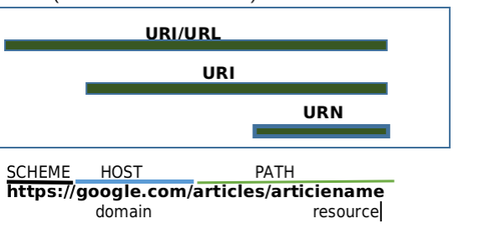**

**variable:** variable is a container which is store value and also hold the value.

**cokkies:** Cokkies is just a file which is contain information for the server.

**GIT:**

it is version control system is a tool that which is help to changes in code.git one of the most pupular version system tool.it is free and open source and it is fast and scalable. it is track the history.

**GITHUB:**

it is website which is allow developers store and manage their code using git. you can upload you website folder for show your work.

first of all download your git from (https://git-scm.com/downloads) and create a github profile account here(https://github.com/)

**SETTING UP GIT:**

visual studio code .

windows (git bash)

mac (terminal)

|  |  |
| --- | --- |
| **code** | **informaiton** |
| git --verson | check version of git |
| **configure git** |  |
| git config --global user.name “my name” | set your name |
| git config --global user.email “my email” | set your email |
| git config --list | show your list of name and email |
| **clone and status** |  |
| git clone some link(git clone https://github.com/pradeepprajapati9/student\_project.git) | cloning a repository on our local machine |
| git status | display the status of the code |
| cd | change directory |
| ls | show sub file from folder |
| ls- a | show hidden files from folder |
| **add and commit** |  |
| git add file name | add new or changes files in your working directory to the git staging area. |
| git commit -m “some massage” | it is record of the changes |
| git add . | git add dot means all file add |
| git push origin main | push-upload local repos content to remote repos |
| mkdir foldername | make new folder in vs via command |
| . .. git | it means your folder is git repo |
| foldername git init | then your folder make as a git repo |
| git remote add origin link | github repo set in local |
| git remote -v | to verify your git repo origin |
| git branch | to check branch |
| git branch -M main | to rename branch name |
| git push -u origin main | -u it means if you want long time work on this project then only you give command git push not git push origin main |
| git checkout -b branch name | create new branch |
| git checkout | show all branch name |
| git checkout branch name | move to another branch |
| git branch -d branch name | branch delete |
| git push origin branch name | it means which branch you want to save |